Problem With Importing Secure CRT sessions

Running RDM version 10.6.5.0 on Windows 7 Servie Pack 1

Process im using attempting to Import my Secure CRT from version 7.3.1 -- sessions into RDM.

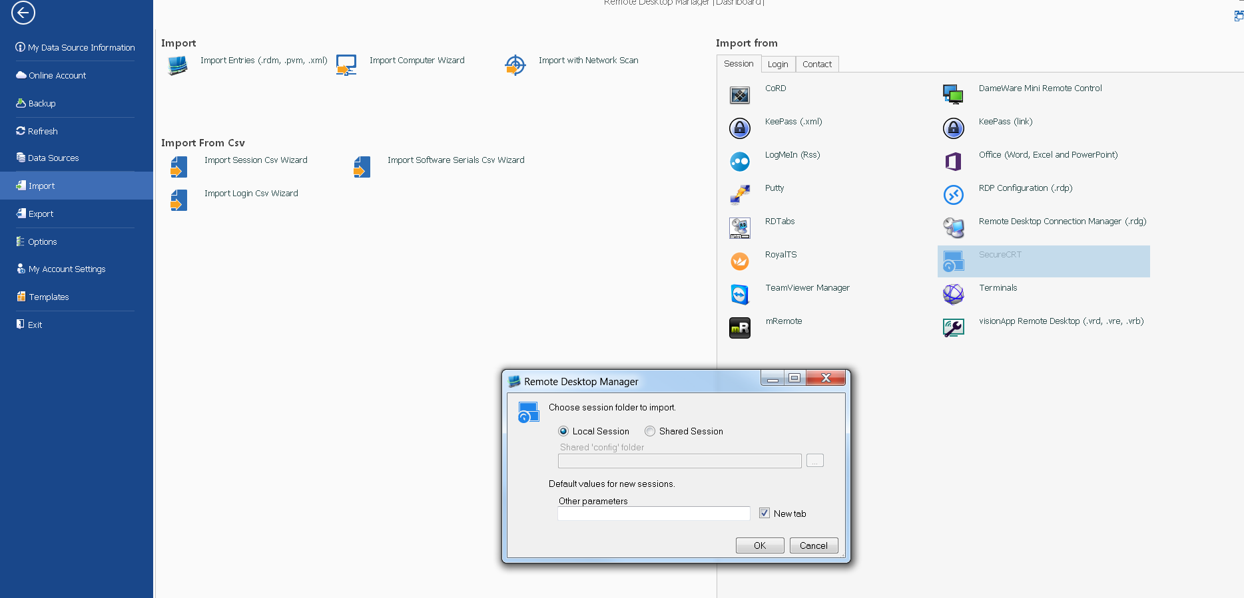

Since the local session is grayed out I choose shared session put path in then get this error message

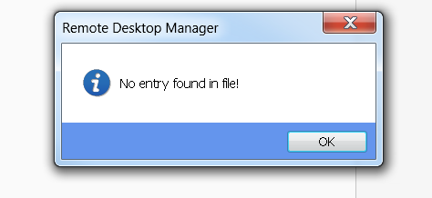

The importer is not working -- Help !!!!

Thank You

