CyberArk Dashboard and priviledged account selected
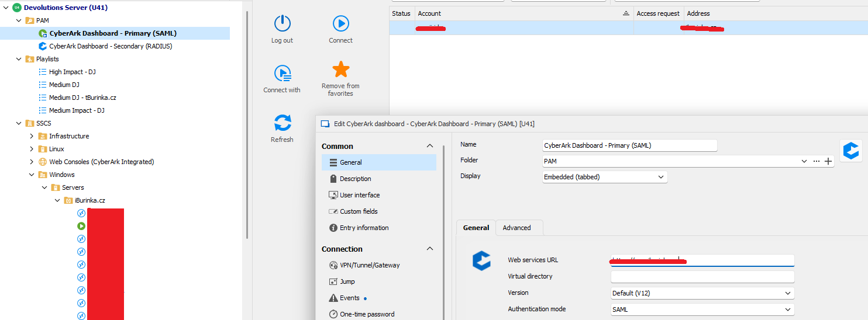

Connect using functionality for RDP
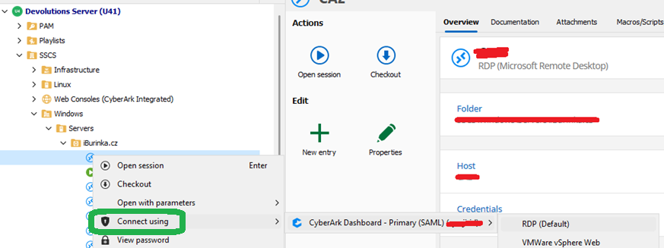

Missing „Connect using“ functionality for playlist as above ?
