Hi, Support,

I hope that you can help me with a Passwordstate issue. We have actifated 2FA for our Passwordstate website and are using RDM with the Passwordstate login option in RDM. See printscreens.
It whould seem that Passwordstate dus not support 2FA in RDM. Can you solfe this for us or do you have a workrouns/salution we my use.
Thanks in adfance

Greetings Michael ten Haaf
Easy Systems
Login of the Passwordstate website
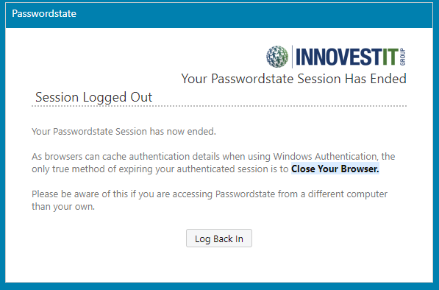
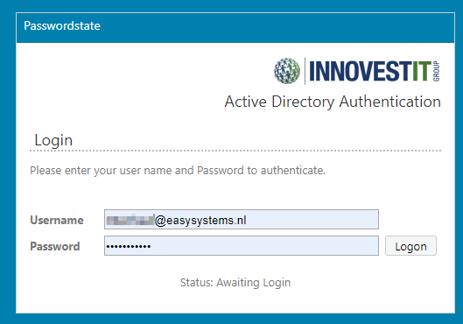

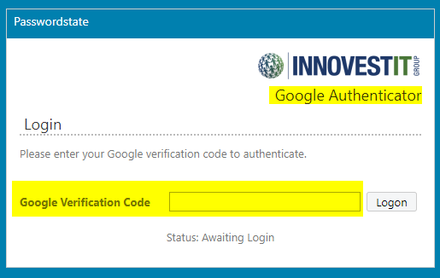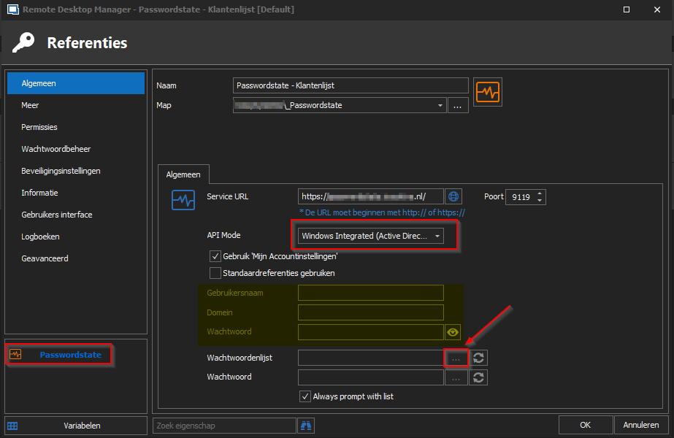

Passwordstate does not return the list we need for the login.